The database of early farming sites of the south of the Eastern Europe (version 0.9-15.05.2021)
Dmytro Kiosak

The database for the project "FUZZFARM" is based on the database for archaeological heritage protection developed in 2018 and adopted for further field-works in Odessa, Mykolaiv and Kirovohrad regions of Ukraine (pre-project database). In the course of the project the structure of some tables is modified in order to make them comply better to the general objectives of the project, while the overall structure of the pre-project database is retained "as it was".
The pre-project database creation consisted of a series of structural processes. To begin with, overall database structure and system requires to be developed according to the ISO series 19110 (Geospatial data and geospatial information codification) with Unified modeling language. According to this standards, the general construction of geospatial database consists of a conceptual diagram, structural diagram and logical diagrams of the database. This schemes include all the information on the internal structure of database and the data inside. It should be considered as database pre-Data, and developed and structured before the data processing begins.
The data interpretation and the content of classes tables depends also on the constraints (both semantic and spatial ones) and classificators of the database. These data is included into the overall logical model of the database and described separately with a “constraints tables”. The list of clasificators and classes are also provided by separate table and activated by a number of triggers. All of these must be developed before the data acquisition starts.
The data include a number of structured tables, connected in correspondence with conceptual database model and fulfilled with the spatial and contextual archaeological information.

The pre-data for the database is as follows:
1. Conceptual diagram of the database (the inner and outer content of the classes tables) that describes the entities of database and the relation between the data units

: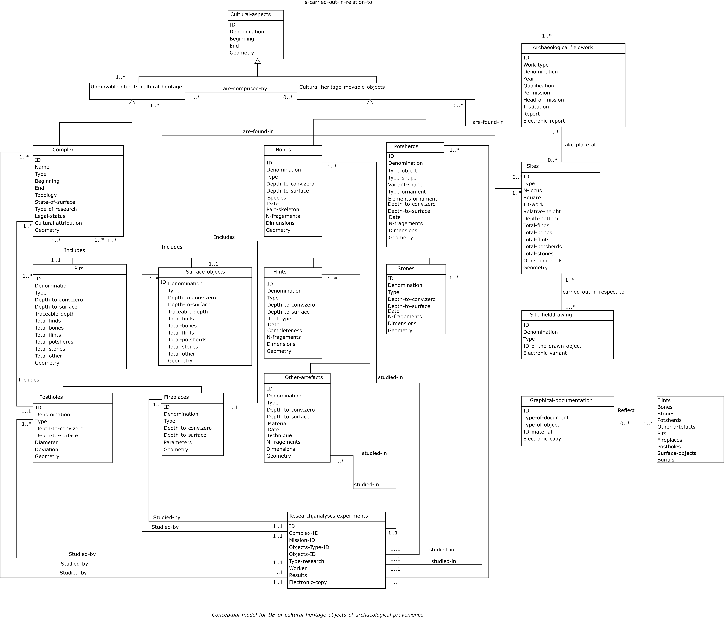

Structural diagram that lists and structures the sources of the data and the contextual basis for their maintenance:
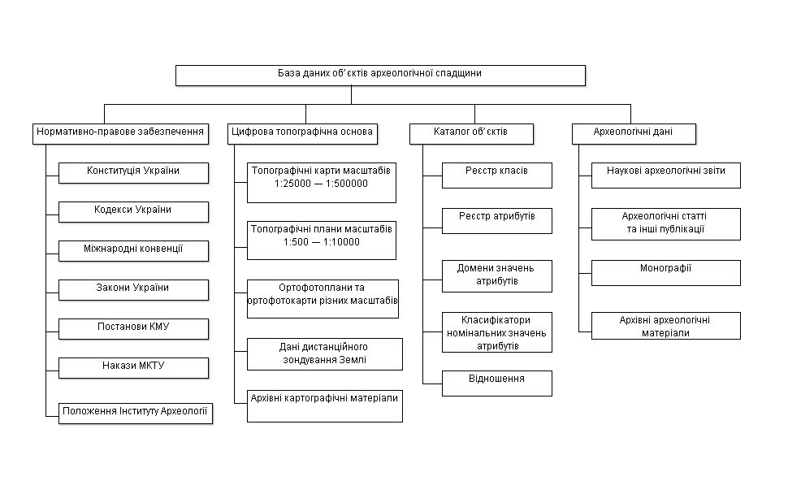
Logical diagram that describes the classes tables and reveals their inner structure, relation between spatial and semantic data etc. Logical diagrams for each table include the list of attributes together with their relevant parameters and contextual meaning.
Name of group | Archaeological culture
Name of class | Archaeological culture
Class ID | ArcCulture
Class code | 10 100 100
Definition | A constant correlation of the archaeological remains of different types, united by a common territory and a common timeline.
Description | Archaeological cultures are defined by common features detected on the sites of different types.

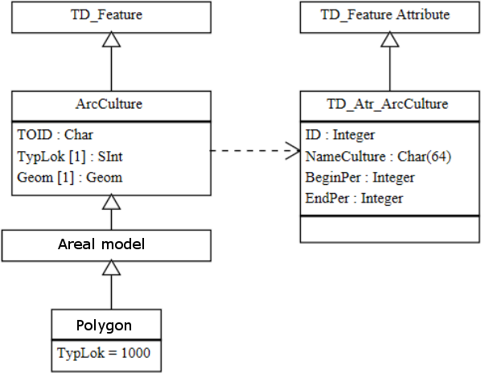

Attributes catalogue
ID | Object's identificator
Definition | Unique object's identificator
Type of data | integer | Status | Main | Code | 010101
Domain | System identificator |  |  | Unit | -
Name culture | Denomination of archaeological culture
Definition | Generally accepted name of cultural aspect
Type of data | Characters row (64) | Status | Main | Code | 010102
 | A set of characters |  |  | Unit | -
BeginPer | The start date of the chronological interval
Definition | The conventionally accepted start date of a chronological interval
Type of data | Integer | Status | Main | Code | 010103
Domain | [-30000;2000] |  |  | Units | Years
EndPer | The end date of the chronological interval
 | The conventionally accepted end date of a chronological interval
Type of data | Integer | Status | Main | Code | 010104
Domain | [-30000;2000] |  |  | Units | Years
 | Geometry type: polygon with an area |  |  | Status | Derivative

In order to develop the database for the project FUZZFarm we concentrated on the elaboration of the table "complexes".
It includes the following columns:
Name | Definition | Type of data | Range of possible values
wkt_geom | geometry of a polygon encompassing a site's area | Geometric
id | Systematic identificator of a site | Integer | Starting from 1
namecomplex | Name of the site as accepted in the regional heritage lists | Text | -
kodtypecomplex | Type of complex | Integer | See classificator
beginper | The start date of the chronological interval | Integer | [-30000; 2000]
endper | The end date of the chronological interval | Integer | [-30000; 2000]
absvys | Absolute height of the site | Integer | -
kodstankompl | The surface conditions of the sites | Integer | See classificator
kodstandosl | The type of research carried out on the site | Integer | See classificator
kodpravstat | The legal status of the site | Integer | See classificator
fazarozv | The phase of the cultural development, varies depending on the archaeological culture | Text | See classificator
IDosnculture | The archaeological culture | Integer | See classificator
L | Length of the finds distribution on the surface | Integer | -
W | Width of the finds distribution on the surface | Integer | -
Topo-position | Topographic position of the site | Text
Tributary | The main river and an order of the tributary on which the site is situated | Text | F.e. "Dniester-2" – the second order tributary of Dniester river
aspect | the name of the cultural aspect (inside the culture) if ever defined | Text | -
Area1 | Area of the site in hectares | Rational | as defined by authors of discovery
Exposition | The principal area of outlook from the site | Text | cardinal directions: f.e. SW, NE

Additional data include the list of classificators and their description:
Classificator for | kodtypecomplex
Name | Abbreviation | Code
Settlement |  | 1
Burial-field |  | 2
Separate finds |  | 3
Encampment |  | 4
Separate burial |  | 5
Separate find in other cultural context |  | 6

Classificator for | kodstankompl
Name | Abbreviation | Code
Excellent |  | 1
Satisfactory |  | 2
Poor |  | 3
Destroyed |  | 4
Unidentified |  | 5

Classificator for | kodstandosl
Name | Abbreviation | Code
Survey |  | 1
Test-trenches |  | 2
Excavations |  | 3
Unknown |  | 4

Classificator for | kodpravstat
Name | Abbreviation | Code
Protected |  | 1
Protected with prohibition of agricultural activities |  | 2
Protected with prohibition of building activities |  | 3
No legal status |  | 4
Unidentified |  | 5

Classificator for | fazarozv
Name of culture | Abbreviation | Code
Trypillia | A1, A2, A3, B1, B1-2, B2, C1, C2
LBK | Altere, Notenkopf, Zielizovice
Cris | 3, 4
Gumelnita | A1, A2
Unidentified | uniden

Classificator for | IDosnculture
Name | Abbreviation | Code
LBK |  | 1
Cris |  | 2
Trypillia A |  | 3
Trypillia B |  | 4
Gumelnita |  | 5
Lublin-Volyn |  | 6

The gathered data are presented in a form of QGIS shapefile and a related csv table. They can be found as supplementary materials to this text.

